Screen shot specifics:

Name of facility: Change to Shady Elms

User Name: Chris Smith

Screen 1: - Enter Diagnosis

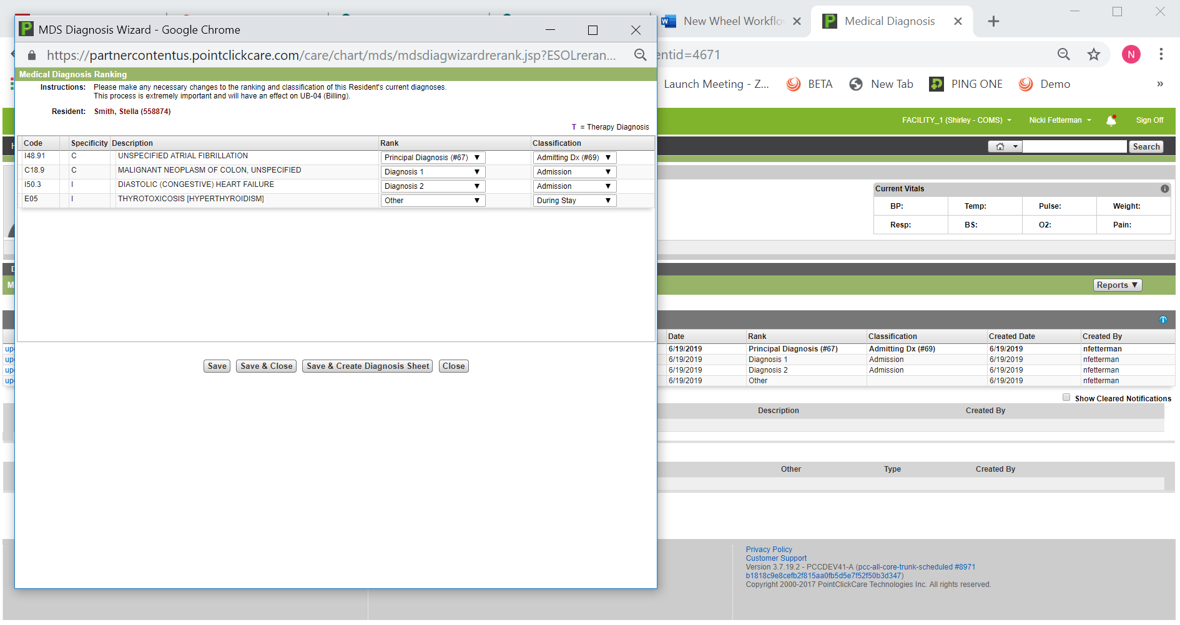

Screen 2: Diagnosis trigger Care Pathways

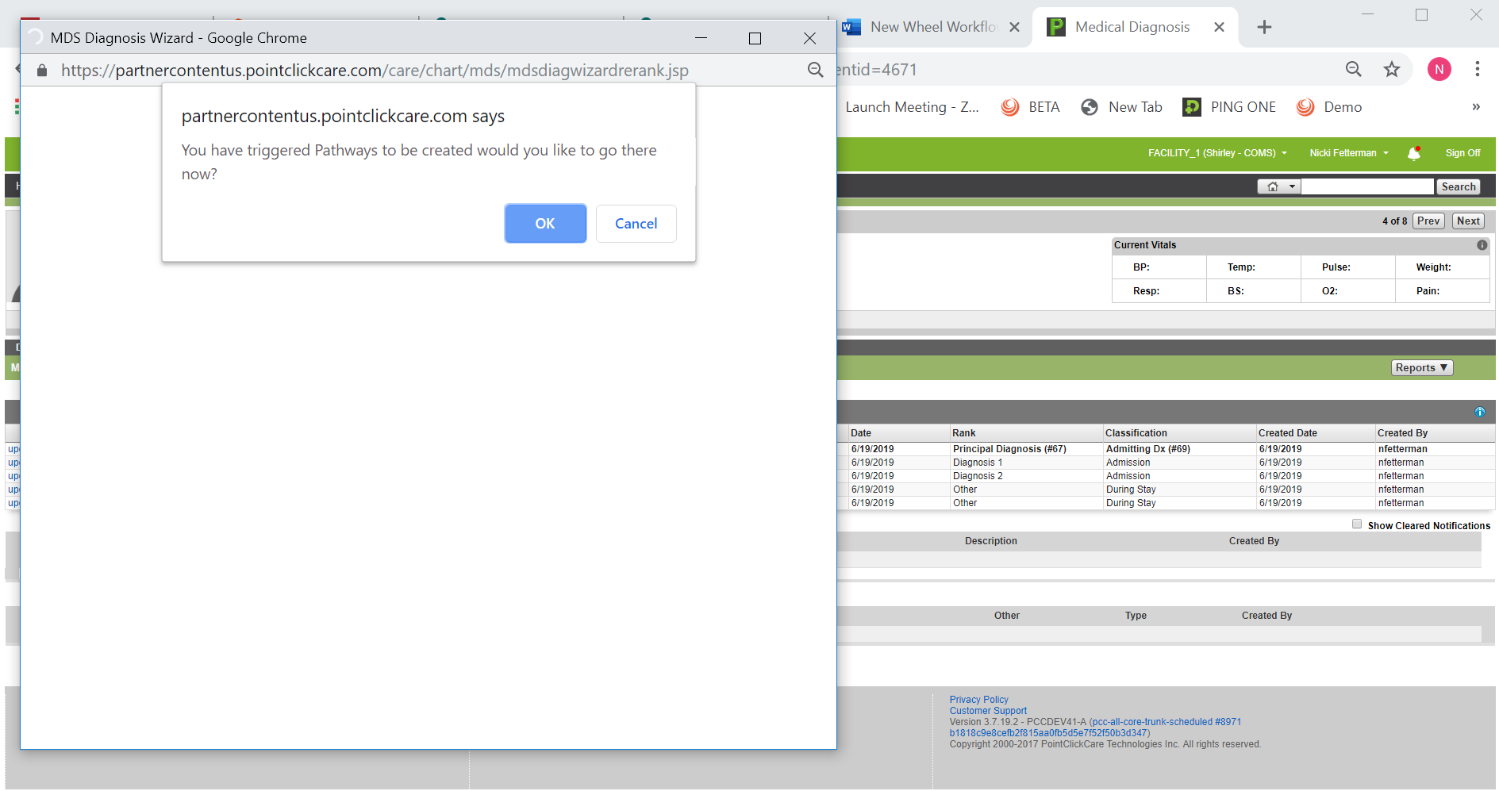

Screen 3: Show Care Pathways

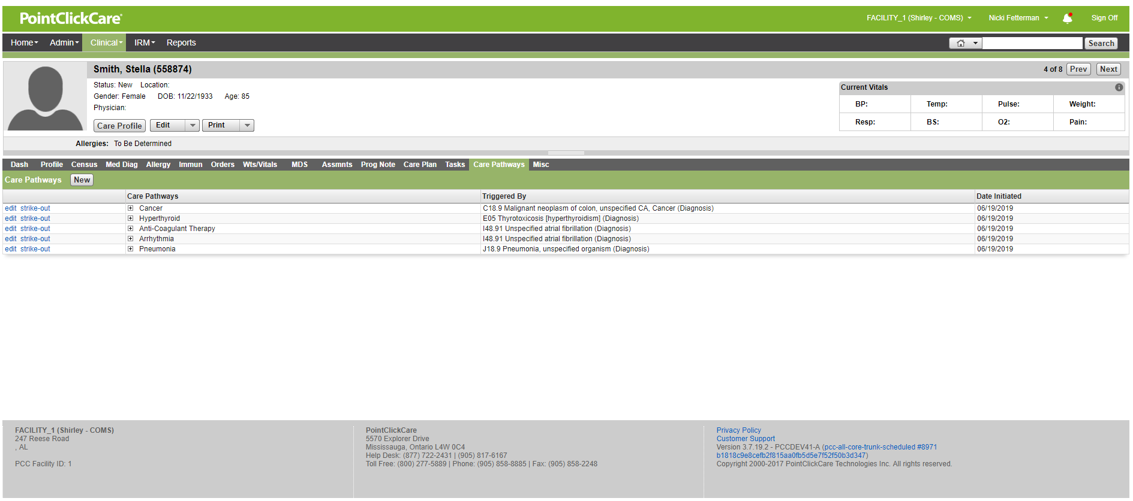

Screen 4: Generate Care Plan – View Triggered Items

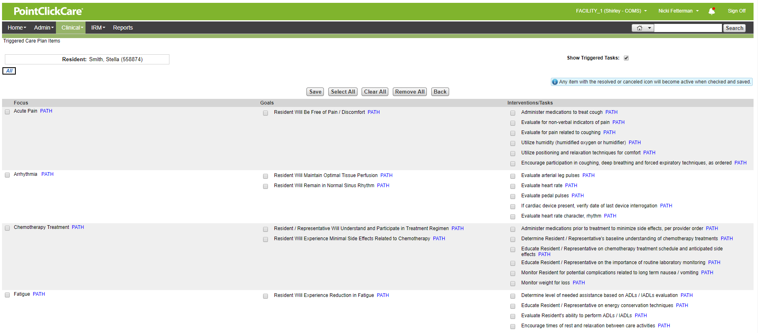

Screen 5: Review & Accept Triggered items

-note we will have to add hot spots so that when the following areas are touched they are shown/outlined. This will not be a page in the workflow but, an added feature

1. click on Path by acute pain – show care pathway. Unable to capture in screen shot. Added this in text box.

2. Red outline surrounds “If cardiac device present, verify data ….” If that area is selected.

3. Red outline surrounds the entire Chemotherapy grouping when area is selected.

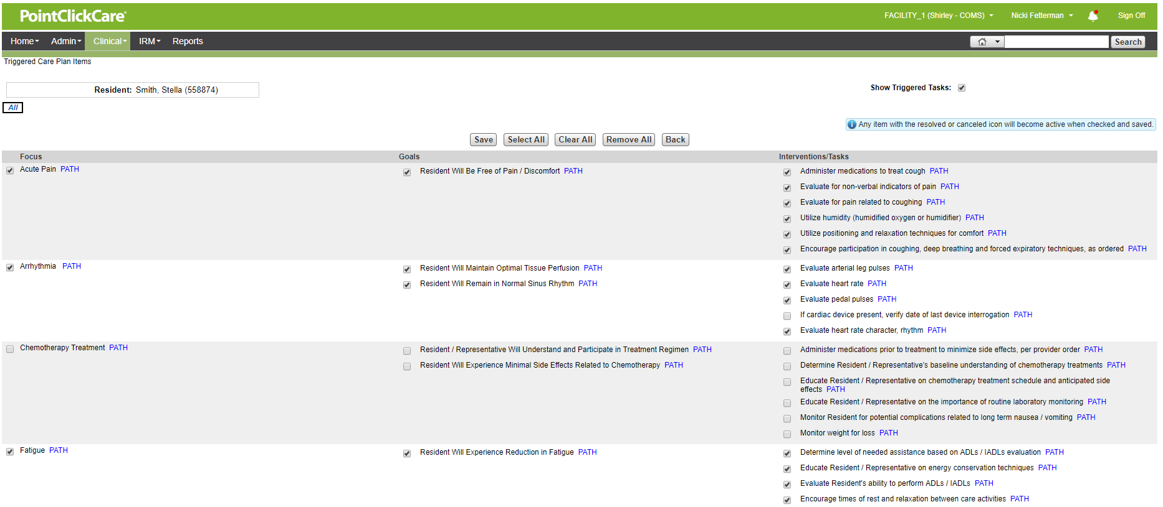

6/19/2019

Cancer

Screen 6: Personalizing Care Plan

I have personalized the Focus and added a custom goal.

1. Red circle appears when “related to colon cancer is touched”
2. Red circle appears when Ms. Smith ….. is touched.

